SWE20004 Technical Software Development Semester 1 2019

Assignment 2 Report

Name: Franz Tamani Student ID: 102114822

Lab class: Thursday / 4:30 / EN302 Tutor: Gavin Chan

Due Date: Monday 6th May 2019 at 11:59 pm

Date Submitted: Wednesday 2st May 2019 at 08:35 pm

Assignment Title: 1

Program description

The application checks if a given credit card number is a valid credit card number or an invalid credit card number by making use of the Luhn Algorithm.

Inputs and Outputs
The inputs and outputs for this program are described in Table 1.

Table 1. Data dictionary:
Data to be stored | Sample data | Type of data | C++ type | Input method | In /  Out | Variable name
User Input | “4” | Number | int | cin | in | Input_number
Card Number | “524323” | Number Array | Int[] | - | out | card_number
Sum1 | “50” | Number | int | - | out | sum1
Sum2 | “40” | Number | int | - | out | sum2
Checksum | “5” | Number | int | - | out | checksum

3. Algorithm
Program steps:
  - Create Variables
  - Prompt User for Input
  - Enter the number
  - If number is -1 go to h
  - Enter number into card array
  - size = amount of numbers entered
  - Repeat c until 20 numbers have been entered
  - Output the numbers that were entered
  - Find sum1
  - Print sum1
  - Find sum2
  - Print sum2
  - Find checksum
  - Print checksum
  - Print last value of card array
  - Print out whether card number entered is a valid credit card number

Sum1 logic:
Every second number from the left excluding the last digit is doubled, if the doubled number is > 9 split the digits and add them to the result. Else add the single digit doubled value to the result.

Sum2 logic:
Every other number that was not used in Sum1 function excluding the last number is added together in order to get the result.

Checksum logic and Valid card logic:
The checksum is the remainder of (Sum1 + Sum2) * 9) /10, the remainder is then compared with the last number in the card number to determine whether it is a valid card number or not. If the checksum and last number are the same, the card is valid.

Source code:

/*
Name: Franz Tamani
StuID: 102114822
Unit: SWE20004 - Technical Software Development
Summary: Program determines whether a given
card number is valie or not.
*/

#include<string>
#include<iostream>

using namespace std;

int find_sum1(int num[], int size)
{
int result = 0;
int sum1[10]; //Numbers will be no more than 10
int j = 0; //Used as counter
int num1 = 0; //Used for number 10+
int num2 = 0; //Used for number 10+

//Size - 2 as last number us ignored
for (int i = size - 2; i >= 0; i -= 2)
{
sum1[j] = num[i];

num[i] *= 2;
if (num[i] > 9)
{
num1 = num[i] % 10; //Extracts first digit ie 15 = 1 & 5, 5 is extracted.
num2 = num[i] / 10; //Extracts second digit ie 15 = 1 & 5, 1 is extracted.
//cout << "Num1 = " << num1 << ", Num2 = " << num2 << endl;
result += (num1 + num2);
}
else
{
result += num[i];
}
j++;
}

//Prints out numbers being used in find_sum1
cout << "Numbers for sum1 are ";
for (int i = 0; i < j; i++)
{
cout << sum1[i] << " ";
}
cout << endl;

return result;
}

int find_sum2(int num[], int size)
{
int result = 0;
int sum1[10]; //numbers will not be longer that 10
int j = 0; //Used as a counter

//Size - 3 as last number us ignored
//And - 2 already done in find_sum1
for (int i = size - 3; i >= 0; i -= 2)
{
sum1[j] = num[i];
result += num[i];
j++;
}

//Prints out numbers being used in find_sum2
cout << "Numbers for sum3 are ";
for (int i = 0; i < j; i++)
{
cout << sum1[i] << " ";
}
cout << endl;
return result;
}

int main()
{
int card_number[20]; //Used for card number storage
int input_number; //Used for user input
int size; //Stores Size of Array
int sum1; //Stores Sum1
int sum2; //Stores Sum2
int checksum; //Stores Checksum

cout << "Enter a Credit Card Number" << endl;

//Just to stop errors when checking the array values
//Initialise all with 0
for (int i = 0; i < 20; i++)
{
card_number[i] = 0;
}

for (int i = 0; i < 20; i++)
{
cin >> input_number;
if (input_number == -1)
break;
else
card_number[i] = input_number;
size = i + 1; // Counter for how many numbers there are.
}

cout << "\nCredit card number is: ";
//Prints out credit card numbers
for (int i = 0; i < size; i++)
{
cout << card_number[i];
}
cout << endl;

sum1 = find_sum1(card_number, size); //Gets sum1
cout << "Sum 1 is " << sum1 << endl;

sum2 = find_sum2(card_number, size); //Gets sum2
cout << "Sum 2 is " << sum2 << endl;

checksum = ((sum1 + sum2) * 9) % 10; //Gets checksum
cout << "Check sum is " << checksum << endl;
cout << "Last digit on credit card is " << card_number[size - 1] << endl;

//Checks if Card Number is Valid or Not
if (checksum == card_number[size - 1])
cout << "Check sum " << checksum << " and the last digit "
<< card_number[size - 1] << " are the same: Valid credit card number" << endl;
else
cout << "Check sum " << checksum << " and the last digit "
<< card_number[size - 1] << " are not the same: Invalid credit card number" << endl;
}

Screenshots showing working program (Show all possible outcome):

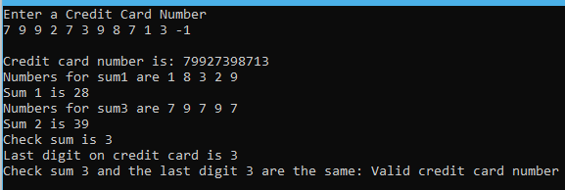
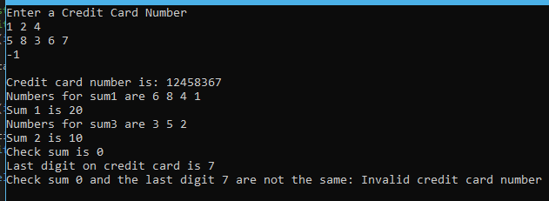
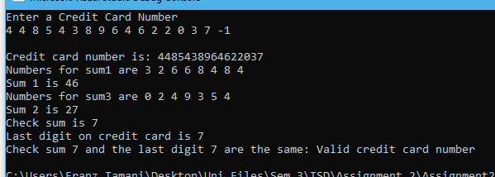

Task 5.3

Program description
The program is a game that generates a random number and has the user guess the number while being given hints.

Source Code
/*
Name: Franz Tamani
StuID: 102114822
Unit: SWE20004 - Technical Software Development
Summary: Program generates a random number
Users guesses what the input is and
is given hints to help.
*/

#include <iostream>
#include <cstdlib>
#include <ctime>

using namespace std;

void guessgame(void);
bool isCorrect(int, int);
void display(int);

int main()
{
srand(time(0));
guessgame();
return 0;
}

void guessgame()
{
int answer, guess, total;
char response;

total = 1;
do
{
answer = 1 + rand() % 1000;
cout << "I have a number between 1 to 1000" << endl;
cout << "Can you guess my number? (Do you feel lucky?)" << endl;
cout << "Please enter your first guess: ";
cin >> guess;
while (!isCorrect(guess, answer))
{
cout << " Try again: ";
cin >> guess;
total++;
}
cout << "\nExcelent! You guessed the number!" << endl;
display(total);
cout << "\nDo you want to play again?" << endl;
cout << "Please Enter (y/n)? ";
cin >> response;
} while (response == 'y');
}

bool isCorrect(int g, int a)
{
if (g == a)
{
return true;
}
else if (g > a)
{
cout << "\nToo High.";
}
else if (g < a)
{
cout << "\nToo Low.";
}
return false;
}

void display(int t)
{
cout << "You tried a total of " << t << " times" << endl;
if (t < 5)
{
cout << "Either you're cheating or just lucky" << endl;
}
else if (t == 10)
{
cout << "Better luck next time lol" << endl;
}
else
{
cout << "You should be able to do better!" << endl;
}
}

Screenshots showing working program
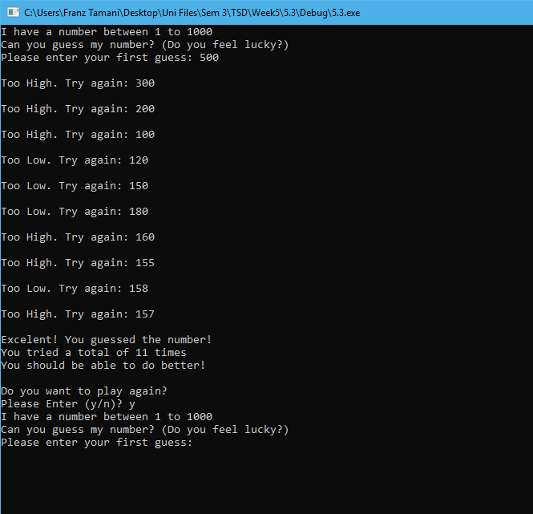

Task 7.3

Program description
The application gets alphabetic input from user and sorts orders them by alphabetical order, it then finds the mode/most occurring letter.

Source Code

/*
Name: Franz Tamani
StuID: 102114822
Unit: SWE20004 - Technical Software Development
Summary: Gets alphabetical input from user and
inserts into an array, which is then sorted.
Program also finds the most occurring alphabet.
*/
#include<iostream>

using namespace std;

#define SIZE 20

void sort(char arr[SIZE])
{
//Sorts the array
for (int i = SIZE - 1; i > 0; i--)
{
for (int j = 0; j < i; j++)
{
if (arr[j] > arr[j + 1])
{
swap(arr[j], arr[j + 1]);
}
}
}
//Outputs sorted array
cout << "\n\nThe Sorted Array is:\n" << endl;
for (int i = 0; i < SIZE; i++)
{
cout << arr[i];
}
}

//Finds the most frequent number in the array
void frequent(char x[SIZE])
{
//Sourced from Week 7, sample solution
int max = 0, i;
char mode;
int fre[SIZE];

for (i = 0; i < SIZE; i++)
{
fre[i] = (int)x[i]; //copy the array
}

for (i = 0; i < SIZE; i++)
{
//Resers counter to 0 each loop
//assigns character to a character in the array
char character = fre[i];
int counter = 0;
for (int j = 0; j < SIZE; j++)
{
//if number is the same as
if (character == fre[j])
counter++;
}
//If counter is greater than max, then another number
//that occcurs more frequently is found
if (counter > max)
{
mode = character;
max = counter;
}
}

//All Chars the same
if (max == 20)
{
cout << "\n\nAll the characters are the same" << endl;
}
//1 character is most occuring
else if (max > 1 && max < 20)
{
//We add 'a' and cast as character for printing.
cout << "\n\nThe mode is " << mode << " occuring " << max << " times" << endl;
}
//All characters unique
else
{
cout << "\n\nAll Characters are Entered Only One Time" << endl;
}
}

int main()
{
char arr[SIZE], input;

cout << "Enter 20 Alphabets" << endl;
//Gets and validates user input
for (int i = 0; i < 20; i++)
{
while (!((cin >> input) && ((input >= 'a' && input <= 'z'))))
{
cout << input << " is not an alphabet" << endl;
cin.clear();
cin.ignore();
}
if (find(begin(arr), end(arr), input) != end(arr))
{
cout << input << " is a duplicate letter" << endl;
}
arr[i] = input;
}

//Outputs original array order
cout << "\n\nThe Original Array is:\n" << endl;
for (int i = 0; i < SIZE; i++)
{
cout << arr[i];
}

//Sorts and Prints Array
sort(arr);

//Prints frequency
frequent(arr);
}

Screenshots showing working program
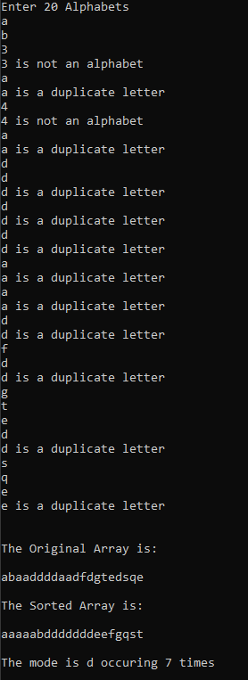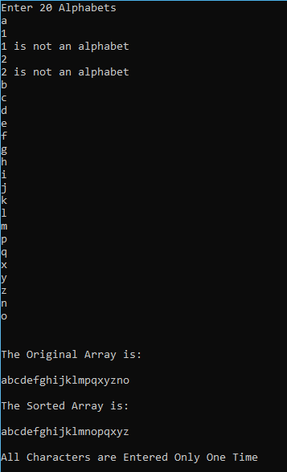

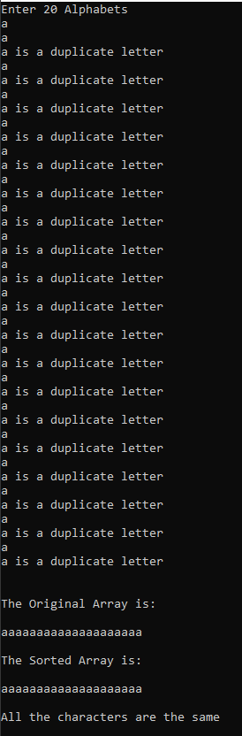

Task 7.4

Program description

The application displays the popularity of certain players in different states given by user input

Source Code

/*
Name: Franz Tamani
StuID: 102114822
Unit: SWE20004 - Technical Software Development
Summary: Find the popularity of players
in different states.
*/
#include<iostream>
#include<iomanip>

using namespace std;

#define SIZE 5

int main()
{
int arr[SIZE][SIZE], player, i, j;
bool loop = true;
char city;
//Initialize all values to 0
for (i = 0; i < SIZE; i++)
{
for (j = 0; j < SIZE; j++)
{
arr[i][j] = 0;
}
}

cout << "City " << setw(20) << "Player" << endl;
cout << "M - Melbourne" << setw(20) << "1 - Ricky Ponting" << endl;
cout << "S - Sydney " << setw(20) << "2 - Shane Warne" << endl;
cout << "B - Brisbane " << setw(20) << "3 - Donald Bradman" << endl;
cout << "A - Adelaide " << setw(20) << "4 - Glenn McGarth" << endl;

cout << "\nFor each entry, enter the city code\nfollowed by the person code."
<< "\nEnter the letter X to indicate end.\n" << endl;
do
{
cin >> city;
if (city == 'X') break;
cin >> player;
if (player > 4 || player < 1) break;
switch (city)
{
case 'M':
arr[1][player] += 1;
break;
case 'S':
arr[2][player] += 1;
break;
case 'B':
arr[3][player] += 1;
break;
case 'A':
arr[4][player] += 1;
break;
}
} while (loop);

cout << "\n------------------------------------------------------------------------------------------" << endl;
cout << setw(50) << "POPULARITY TABLE" << endl;
cout << "------------------------------------------------------------------------------------------" << endl;
cout << "City" << setw(25) << "Ricky Ponting";
cout << setw(20) << "Shane Warne";
cout << setw(20) << "Donald Bradman";
cout << setw(20) << "Glenn McGarth" << endl;
cout << "------------------------------------------------------------------------------------------" << endl;
cout << "Melbourne";
for (i = 1; i <= SIZE - 1; i++)
{
cout << setw(20) << arr[1][i];
}
cout << "\nSydney ";
for (i = 1; i <= SIZE - 1; i++)
{
cout << setw(20) << arr[2][i];
}
cout << "\nBrisbane ";
for (i = 1; i <= SIZE - 1; i++)
{
cout << setw(20) << arr[3][i];
}
cout << "\nAdelaide ";
for (i = 1; i <= SIZE - 1; i++)
{
cout << setw(20) << arr[4][i];
}
cout << "\n------------------------------------------------------------------------------------------" << endl;
}

Screenshots showing working program

